PowerBi Project Documentation – SWETHA.V
Loan Data Documentation
1. Loan Data Dashboard (Report View)
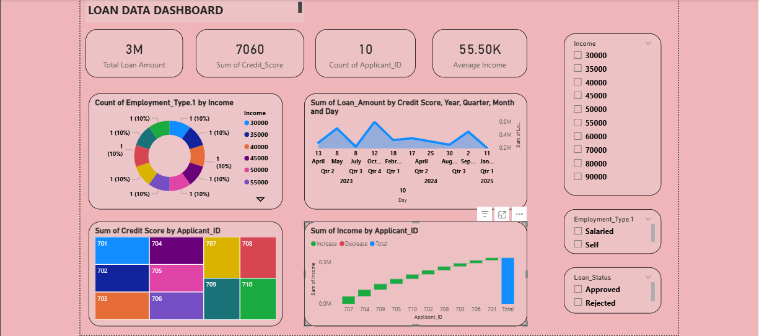

What I Have Done
- Created an interactive Loan Data Dashboard.
- Added KPI Cards:
  - Total Loan Amount → 3M
  - Sum of Credit Score → 7060
  - Count of Applicant_ID → 10
  - Average Income → 55.50K
- Added Visualizations:
  - Donut Chart: Count of Employment Type by Income
  - Line Chart: Sum of Loan Amount by Credit Score (Year, Quarter, Month, Day)
  - Treemap: Sum of Credit Score by Applicant_ID
  - Column Chart: Sum of Income by Applicant_ID
- Added Slicers:
  - Income Filter
  - Employment Type Filter (Salaried / Self)
  - Loan Status Filter (Approved / Rejected)
- Designed background and formatted visuals for better appearance.
Insights from Dashboard
- Total loan amount issued is 3 Million.
- Average applicant income is ₹55,500.
- Higher income applicants tend to receive higher loan amounts.
- Salaried applicants appear more frequently compared to self-employed.
- Credit scores are distributed between 650–780 range.
- Loan amounts increase as credit score increases
2. Applicant Table (Data View – Table Tools)
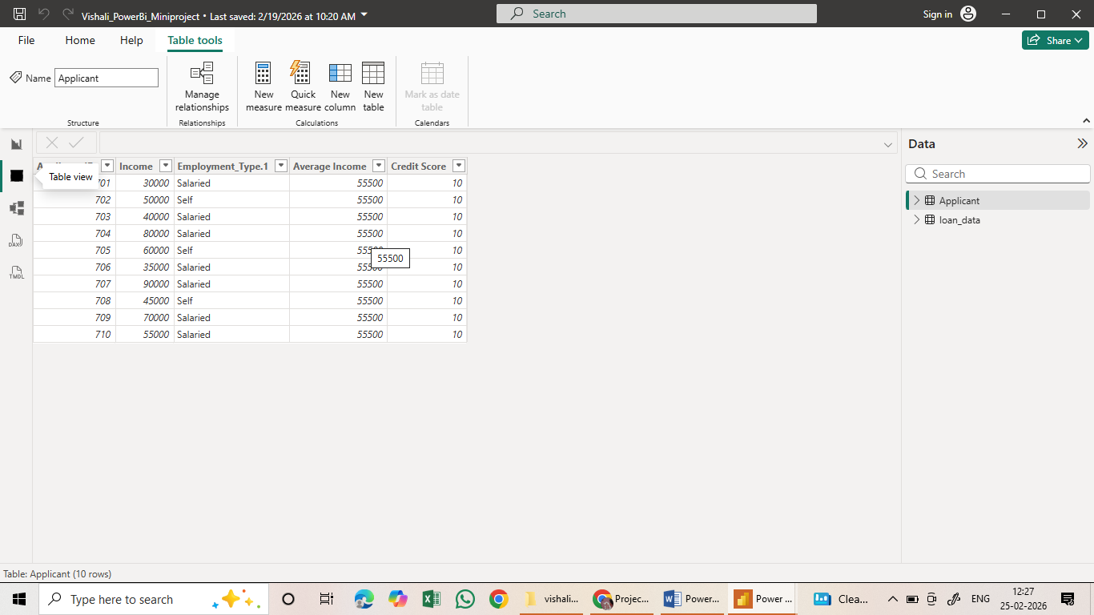

What I Have Done
- Created and structured the Applicant Table.
- Added columns:
  - Applicant_ID
  - Income
  - Employment_Type.1
  - Average Income
  - Credit Score
- Verified 10 applicant records.
- Ensured correct data types (Whole Number format).
- Used this table for dashboard visuals.

Insights from Applicant Data
- Applicant incomes range from ₹30,000 to ₹90,000.
- Majority applicants are Salaried.
- Credit score column prepared for loan eligibility analysis.
- Average income column added for KPI calculation.
3. Model View (Relationships)
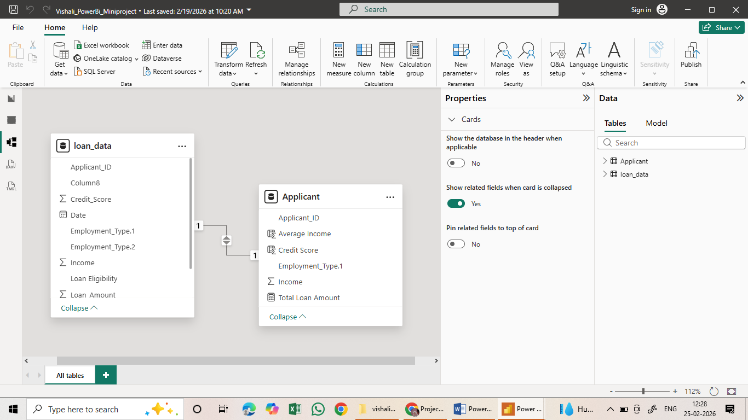

What I Have Done
- Created relationship between:
  - loan_data table
  - Applicant table
- Connected using Applicant_ID.
- Established a One-to-One relationship.
- Enabled cross filtering.
- Organized data model properly.

Insights from Data Model
- Proper relationship allows:
  - Loan Amount analysis by applicant
  - Income comparison with loan amount
  - Employment type-based filtering
- Data model ensures accurate calculation in visuals.
- Prevents duplication and aggregation errors.
4. Power Query Editor – loan_data Table
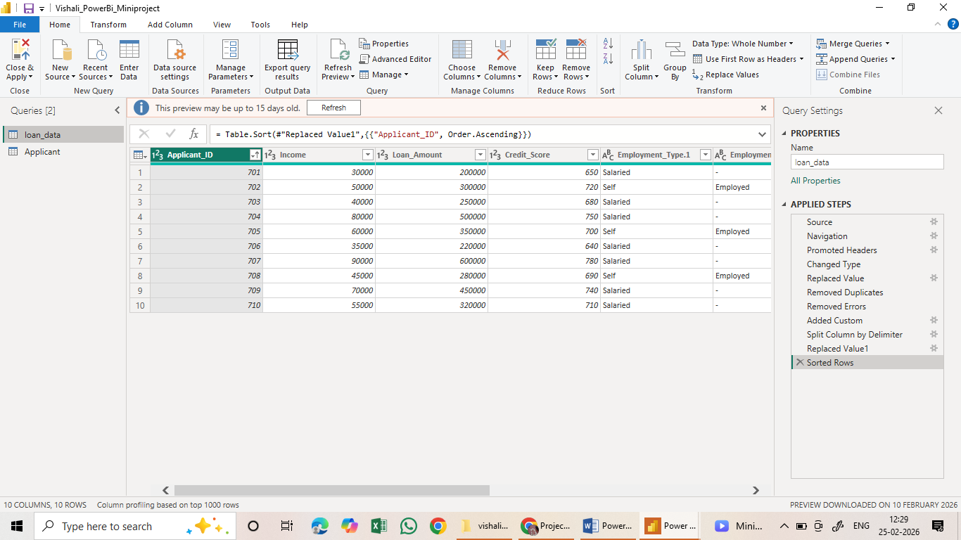

What I Have Done
- Imported data into Power BI.
- Applied the following transformations:
  - Promoted Headers
  - Changed Data Types
  - Replaced Values
  - Removed Duplicates
  - Removed Errors
  - Added Custom Column
  - Split Column by Delimiter
  - Sorted Rows by Applicant_ID
- Cleaned Employment Type column.
- Prepared Loan_Amount and Credit_Score columns for analysis.

Insights from Data Cleaning
- Cleaned data ensures accurate dashboard results.
- Removed duplicates to avoid incorrect totals.
- Sorted data improves readability.
- Replaced incorrect or null values.
- Structured dataset ready for reporting.

